Apache Spark: Setting Default Values
Using a default value instead of 'null' is a common practice, and as a Spark's struct field can be nullable, it applies to DataFrames too. Let's say that we have a DataFrame of music tracks playing with the following schema:
root
|-- id: string (nullable = false)
|-- trackId: string (nullable = false)
|-- trackLength: long (nullable = true)
|-- albumId: string (nullable = true)
|-- completionPercentage: double (nullable = true)
|-- totalPlayedMillis: long (nullable = false)

And we want to find:
- Plays that are less than 30 seconds
- Plays that are more than 1 minute with a completion percentage greater or equal to 80%
For both of the queries, we need to set default values:
- "no album" if 'album' is 'null'
- 0 if 'completionPercentage' is 'null'.
These queries could be written as:
Dataset<Row> dataFrame = session.createDataFrame(source, structType);
Dataset<Row> playsLessThan30seconds = getPlaysLessThan30seconds(dataFrame);
Dataset<Row> playGte1minuteWithCompletionGte80 = getPlayGte1minuteWithCompletionPercentageGte80(dataFrame);
...
private static Dataset<Row> getPlaysLessThan30seconds(Dataset<Row> dataFrame) {
return dataFrame
.select(
col("id"),
col("trackId"),
coalesce(col("albumId"), lit("no album"))
.as("albumId"),
col("trackLength"),
coalesce(col("completionPercentage"), lit(0.0D))
.as("completionPercentage")
)
.where(col("totalPlayedMillis").lt(30000L));
}
private static Dataset<Row> getPlayGte1minuteWithCompletionPercentageGte80(Dataset<Row> dataFrame) {
return dataFrame
.select(
col("id"),
col("trackId"),
coalesce(col("albumId"), lit("no album"))
.as("albumId"),
col("trackLength"),
coalesce(col("completionPercentage"), lit(0.0D))
.as("completionPercentage")
)
.where(col("totalPlayedMillis").gt(60000L)
.and(col("completionPercentage").geq(0.8D)));
}

The result for a test dataset is:
+---------------------------------------------------------------------------------------------+
| Plays less than 30 seconds | |
+----------+----------------+--------------------------------+-----------+--------------------+
|id |trackId |albumId |trackLength|completionPercentage|
+----------+----------------+--------------------------------+-----------+--------------------+
|oZzaToTxqy|I Keep Coming |0 |360000 |0.06388888888888888 |
|bejFaTssDw|Una palabra |no album |180000 |0.10555555555555556 |
|jtydOYuSkJ|A 1000 Times |I Had A Dream That You Were Mine|240000 |0.0 |
+----------+----------------+--------------------------------+-----------+--------------------+
+--------------------------------------------------------------------------+
| Plays gte 1 minute with completion percentage gte 80% |
+----------+---------------------+--------+-----------+--------------------+
|id |trackId |albumId |trackLength|completionPercentage|
+----------+---------------------+--------+-----------+--------------------+
|nJXKxjobwo|Wrench and Numbers |Fargo |300000 |0.8 |
|svyULOUcKC|Dutch National Anthem|no album|300000 |0.8666666666666667 |
+----------+---------------------+--------+-----------+--------------------+

Unfortunately, C&P comes in to play, therefore, if at some point in time a default value for 'trackLength' is also required, you may end up changing both of these methods. Another disadvantage is that if another similar method, which requires the same default values, is added, code duplication is unavoidable.
A possible solution, which helps to reduce boilerplate, is DataFrameNaFunctions, which is intended to be used for handling missing data: replacing specific values, dropping 'null' and 'NaN', and setting default values:
Dataset<Row> dataFrame = session.createDataFrame(source, structType)
.na()
.fill(ImmutableMap.of(
"albumId", "no album",
"completionPercentage", 0.0D
));
Dataset<Row> playsLessThan30seconds = getPlaysLessThan30seconds(dataFrame);
Dataset<Row> playGte1minuteWithCompletionGte80 = getPlayGte1minuteWithCompletionPercentageGte80(dataFrame);
....
private Dataset<Row> getPlaysLessThan30seconds(Dataset<Row> dataFrame) {
return dataFrame
.select("id", "trackId", "albumId", "trackLength", "completionPercentage")
.where(col("totalPlayedMillis").lt(30000L));
}
private static Dataset<Row> getPlayGte1minuteWithCompletionPercentageGte80(Dataset<Row> dataFrame) {
return dataFrame
.select("id","trackId", "albumId", "trackLength", "completionPercentage")
.where(col("totalPlayedMillis").gt(60000L)
.and(col("completionPercentage").geq(0.8D)));
}

The result is still the same:
+---------------------------------------------------------------------------------------------+
| Plays less than 30 seconds | |
+----------+----------------+--------------------------------+-----------+--------------------+
|id |trackId |albumId |trackLength|completionPercentage|
+----------+----------------+--------------------------------+-----------+--------------------+
|oZzaToTxqy|I Keep Coming |0 |360000 |0.06388888888888888 |
|bejFaTssDw|Una palabra |no album |180000 |0.10555555555555556 |
|jtydOYuSkJ|A 1000 Times |I Had A Dream That You Were Mine|240000 |0.0 |
+----------+----------------+--------------------------------+-----------+--------------------+
+--------------------------------------------------------------------------+
| Plays gte 1 minute with completion percentage gte 80% |
+----------+---------------------+--------+-----------+--------------------+
|id |trackId |albumId |trackLength|completionPercentage|
+----------+---------------------+--------+-----------+--------------------+
|nJXKxjobwo|Wrench and Numbers |Fargo |300000 |0.8 |
|svyULOUcKC|Dutch National Anthem|no album|300000 |0.8666666666666667 |
+----------+---------------------+--------+-----------+--------------------+

Conclusion
Prefer using DataFrameNaFunctions in order to prevent code duplication when the same default values are set in several queries that use the same DataFrame.

Create a Spark DataFrame: Read and Parse Multiple (Small) Files
This is a very specific use case we faced while loading small CSV files in bulk with UTF -16 encoded files. After reading data from a source location, one might see junk/special characters while using DF.show() which may lead to unexpected results.
So, below, I've shown how to read a file in Spark without using the deafault UTF-8 encoded file.
Soln: We have used the below code to solve this; here folderPath can be any HDFS location
val rdd_file = sparkSession.sparkContext.binaryFiles(folderPath, 2).
mapValues(content => new String(content.toArray(), StandardCharsets.UTF_16))
// rdd_file is created as paired RDD like below
//val rdd_file: RDD[(String, String)] à first String represents filename
//second String represents: String content of file
// From rdd_file we can perform map transformation on each file to get RDD as RDD[List[Employee]]
val rddOfListPojo= rdd_file.map{x =>
val fileData = x._2
// parse fileData to get list of Pojo w.r.t business logic
listOfEmployee
}
val rddPojo = rddOfListPojo.flatMap(x => x)
val dsCombined = rddPojo.toDS()
Note: We have created a combined data set called dsCombined (as mentioned above) from the small UTF-16 encoded files.

Spark: Write to CSV File
A couple of weeks ago I wrote how I’d been using Spark to explore a City of Chicago Crime dataset and having worked out how many of each crime had been committed I wanted to write that to a CSV file.
Spark provides a saveAsTextFile function which allows us to save RDDs so I refactored my code into the following format to allow me to use that:
import au.com.bytecode.opencsv.CSVParser import org.apache.spark.rdd.RDD import org.apache.spark.SparkContext._ def dropHeader(data: RDD[String]): RDD[String] = { data.mapPartitionsWithIndex((idx, lines) => { if (idx == 0) { lines.drop(1) } lines }) } // https://data.cityofchicago.org/Public-Safety/Crimes-2001-to-present/ijzp-q8t2 val crimeFile = "/Users/markneedham/Downloads/Crimes_-_2001_to_present.csv" val crimeData = sc.textFile(crimeFile).cache() val withoutHeader: RDD[String] = dropHeader(crimeData) val file = "/tmp/primaryTypes.csv" FileUtil.fullyDelete(new File(file)) val partitions: RDD[(String, Int)] = withoutHeader.mapPartitions(lines => { val parser = new CSVParser(',') lines.map(line => { val columns = parser.parseLine(line) (columns(5), 1) }) }) val counts = partitions. reduceByKey {case (x,y) => x + y}. sortBy {case (key, value) => -value}. map { case (key, value) => Array(key, value).mkString(",") } counts.saveAsTextFile(file)
If we run that code from the Spark shell, we end up with a folder called /tmp/primaryTypes.csvcontaining multiple part files:
$ ls -lah /tmp/primaryTypes.csv/ total 496 drwxr-xr-x 66 markneedham wheel 2.2K 30 Nov 07:17 . drwxrwxrwt 80 root wheel 2.7K 30 Nov 07:16 .. -rw-r--r-- 1 markneedham wheel 8B 30 Nov 07:16 ._SUCCESS.crc -rw-r--r-- 1 markneedham wheel 12B 30 Nov 07:16 .part-00000.crc -rw-r--r-- 1 markneedham wheel 12B 30 Nov 07:16 .part-00001.crc -rw-r--r-- 1 markneedham wheel 12B 30 Nov 07:16 .part-00002.crc -rw-r--r-- 1 markneedham wheel 12B 30 Nov 07:16 .part-00003.crc ... -rwxrwxrwx 1 markneedham wheel 0B 30 Nov 07:16 _SUCCESS -rwxrwxrwx 1 markneedham wheel 28B 30 Nov 07:16 part-00000 -rwxrwxrwx 1 markneedham wheel 17B 30 Nov 07:16 part-00001 -rwxrwxrwx 1 markneedham wheel 23B 30 Nov 07:16 part-00002 -rwxrwxrwx 1 markneedham wheel 16B 30 Nov 07:16 part-00003 ...
If we look at some of those part files we can see that it’s written the crime types and counts as expected:
$ cat /tmp/primaryTypes.csv/part-00000 THEFT,859197 BATTERY,757530 $ cat /tmp/primaryTypes.csv/part-00003 BURGLARY,257310
This is fine if we’re going to pass those CSV files into another Hadoop-based job, but I actually want a single CSV file so it’s not quite what I want.
One way to achieve this is to force everything to be calculated on one partition which will mean we only get one part file generated:
val counts = partitions.repartition(1). reduceByKey {case (x,y) => x + y}. sortBy {case (key, value) => -value}. map { case (key, value) => Array(key, value).mkString(",") } counts.saveAsTextFile(file)
part-00000 now looks like this:
$ cat !$ cat /tmp/primaryTypes.csv/part-00000 THEFT,859197 BATTERY,757530 NARCOTICS,489528 CRIMINAL DAMAGE,488209 BURGLARY,257310 OTHER OFFENSE,253964 ASSAULT,247386 MOTOR VEHICLE THEFT,197404 ROBBERY,157706 DECEPTIVE PRACTICE,137538 CRIMINAL TRESPASS,124974 PROSTITUTION,47245 WEAPONS VIOLATION,40361 PUBLIC PEACE VIOLATION,31585 OFFENSE INVOLVING CHILDREN,26524 CRIM SEXUAL ASSAULT,14788 SEX OFFENSE,14283 GAMBLING,10632 LIQUOR LAW VIOLATION,8847 ARSON,6443 INTERFERE WITH PUBLIC OFFICER,5178 HOMICIDE,4846 KIDNAPPING,3585 INTERFERENCE WITH PUBLIC OFFICER,3147 INTIMIDATION,2471 STALKING,1985 OFFENSES INVOLVING CHILDREN,355 OBSCENITY,219 PUBLIC INDECENCY,86 OTHER NARCOTIC VIOLATION,80 NON-CRIMINAL,12 RITUALISM,12 OTHER OFFENSE ,6 NON - CRIMINAL,2 NON-CRIMINAL (SUBJECT SPECIFIED),2
This works but it’s quite a bit slower than when we were doing the aggregation across partitions so it’s not ideal.
Instead, what we can do is make use of one of Hadoop’s merge functions which squashes part files together into a single file.
First, we import Hadoop into our SBT file:
libraryDependencies += "org.apache.hadoop" % "hadoop-hdfs" % "2.5.2"
Now let’s bring our merge function into the Spark shell:
import org.apache.hadoop.conf.Configuration import org.apache.hadoop.fs._ def merge(srcPath: String, dstPath: String): Unit = { val hadoopConfig = new Configuration() val hdfs = FileSystem.get(hadoopConfig) FileUtil.copyMerge(hdfs, new Path(srcPath), hdfs, new Path(dstPath), false, hadoopConfig, null) }
And now let’s make use of it:
val file = "/tmp/primaryTypes.csv" FileUtil.fullyDelete(new File(file)) val destinationFile= "/tmp/singlePrimaryTypes.csv" FileUtil.fullyDelete(new File(destinationFile)) val counts = partitions. reduceByKey {case (x,y) => x + y}. sortBy {case (key, value) => -value}. map { case (key, value) => Array(key, value).mkString(",") } counts.saveAsTextFile(file) merge(file, destinationFile)
And now we’ve got the best of both worlds:
$ cat /tmp/singlePrimaryTypes.csv THEFT,859197 BATTERY,757530 NARCOTICS,489528 CRIMINAL DAMAGE,488209 BURGLARY,257310 OTHER OFFENSE,253964 ASSAULT,247386 MOTOR VEHICLE THEFT,197404 ROBBERY,157706 DECEPTIVE PRACTICE,137538 CRIMINAL TRESPASS,124974 PROSTITUTION,47245 WEAPONS VIOLATION,40361 PUBLIC PEACE VIOLATION,31585 OFFENSE INVOLVING CHILDREN,26524 CRIM SEXUAL ASSAULT,14788 SEX OFFENSE,14283 GAMBLING,10632 LIQUOR LAW VIOLATION,8847 ARSON,6443 INTERFERE WITH PUBLIC OFFICER,5178 HOMICIDE,4846 KIDNAPPING,3585 INTERFERENCE WITH PUBLIC OFFICER,3147 INTIMIDATION,2471 STALKING,1985 OFFENSES INVOLVING CHILDREN,355 OBSCENITY,219 PUBLIC INDECENCY,86 OTHER NARCOTIC VIOLATION,80 RITUALISM,12 NON-CRIMINAL,12 OTHER OFFENSE ,6 NON - CRIMINAL,2 NON-CRIMINAL (SUBJECT SPECIFIED),2
The full code is available as a gist if you want to play around with it.

How to Process Nasty Fixed Width Files Using Apache Spark
A fixed width file is a very common flat file format when working with SAP, Mainframe, and Web Logs. Converting the data into a dataframe using metadata is always a challenge for Spark Developers. This particular article talks about all kinds of typical scenarios that a developer might face while working with a fixed witdth file. This solution is generic to any fixed width file and very easy to implement. This also takes care of the Tail Safe Stack as the RDD gets into the foldLeft operator.
Let's check the source file first and then the metadata file:
10597 Subhasish Guha subhasish.iot@gmail.com 27 TXNPUES Yes 5007.10 191675 Ritam Mukherjee ritam@gmail.com 29 SINGLE OUNHQEX XUFQONY No 01/14/20133172.53 43537.00 Saurav Agarwal agarwalsaurav@gmail.com 30 MARRIED 100000.00 7000.00 80495 Priyanshu Kumar kumarpriyanshu@gmail.com 45 MARRIED XDZANTV No 11/21/2012
The source file has multiple issues:
- The end field does not have all the spaces.
- The last two fields are not present.
- In between fields, a few things are not present.
The metadata file looks like below:
col_name,size account_id,10 name,50 mail,40 age,3 status,10 desc,27 cflow,3 process_date,10 debit_amt,10 credit_amt,10
Now please look at the generic code which could load the data in a dataframe:
import org.apache.spark.sql.SparkSession import org.apache.spark.sql._ import org.apache.spark.sql.functions._ import org.apache.spark.sql.types._ import org.apache.spark.sql.SQLContext import org.apache.spark.sql.DataFrame import org.apache.spark.sql.functions.{lit,col,concat_ws,split,struct} import org.apache.spark.sql.catalyst.expressions.Explode import org.apache.spark.sql.types.{StructType,StructField,StringType}; import org.apache.spark.rdd.RDD import org.apache.spark.sql.AnalysisException import org.apache.spark.sql.types.StructType import org.apache.spark.sql.types.StructField import org.apache.spark.sql.types.StringType import org.apache.spark.sql.Row import org.apache.spark.sql.types.LongType import org.apache.spark.sql.functions.{lower, upper} import org.apache.spark.sql.functions.col import org.apache.spark.sql.functions.{input_file_name, regexp_extract} import org.apache.spark.sql.functions._ import org.apache.spark.SparkContext import org.apache.spark.SparkConf import scala.reflect.ClassTag object FixedWidth { def lsplit(pos: List[Int], str: String): Row = { val (rest, result) = pos.foldLeft((str, List[String]())) { case ((s, res),curr) => if(s.length()<=curr) { val split=s.substring(0).trim() val rest="" (rest, split :: res) } else if(s.length()>curr) { val split=s.substring(0, curr).trim() val rest=s.substring(curr) (rest, split :: res) } else { val split="" val rest="" (rest, split :: res) } } Row.fromSeq(result.reverse) } def main(args: Array[String]): Unit = { System.setProperty("hadoop.home.dir", "C://winutils//") val spark = SparkSession.builder().master("yarn").config("spark.sql.warehouse.dir", "file:///C://Personalized//").getOrCreate() val rdd= spark.sparkContext.textFile("path of your file") val metadata=spark.read.option("header", "true").csv("path of your Metadata File") val header=metadata.select("col_name").rdd.map(x=>x.getString(0).trim()).collect() val sizeOfColumn=metadata.select("size").rdd.map(x=>x.getString(0).trim()).collect().map(_.toInt).toList val fields = header.map(fieldName => StructField(fieldName, StringType, nullable = true)) val schema = StructType(fields) val df=spark.createDataFrame(rdd.map { x => lsplit(sizeOfColumn,x) }, schema) df.show(false) } }
The output of this code looks like what I've got below. I hope this helps all the developers who are handling this kind of file and facing some problems. This particular code will handle almost all possible discripencies which we face.
+----------+---------------+------------------------+---+-------+---------------+-----+------------+---------+----------+ |account_id|name |mail |age|status |desc |cflow|process_date|debit_amt|credit_amt| +----------+---------------+------------------------+---+-------+---------------+-----+------------+---------+----------+ |10597 |Subhasish Guha |subhasish.iot@gmail.com |27 | |TXNPUES |Yes | |5007.10 | | |191675 |Ritam Mukherjee|ritam@gmail.com |29 |SINGLE |OUNHQEX XUFQONY|No |01/14/2013 |3172.53 |43537.00 | | |Saurav Agarwal |agarwalsaurav@gmail.com |30 |MARRIED| | | |100000.00|7000.00 | |80495 |Priyanshu Kumar|kumarpriyanshu@gmail.com|45 |MARRIED|XDZANTV |No |11/21/2012 | | | +----------+---------------+------------------------+---+-------+---------------+-----+------------+---------+----------+

Optimizing Spark Job Performance With Apache Ignite (Part 1)
Apache Ignite offers several ways to improve a Spark job's performance: Ignite RDD, which represents an Ignite cache as a Spark RDD abstraction, and Ignite IGFS, an in-memory file system that can be transparently plugged into Spark deployments. Ignite RDD allows easily sharing states in-memory between different Spark jobs or applications. With Ignite in-memory shares RDDs, any Spark job can put some data into an Ignite cache that other Spark jobs can access later. Ignite RDD is implemented as a view over the Ignite distributed cache, which can be deployed either within the Spark job execution processor on a Spark worker.
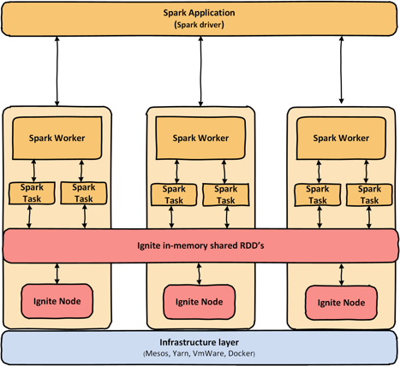
Before we move on to more advanced topics, let's have a look at the history of Spark and what kinds of problems can be solved by Ignite RDDs.

Portions of this article were taken from the book The Apache Ignite book. See more about Spark data frame integration in chapter 7. There is a special 20% discount for the DZone readers, please use the following coupon.
Apache Spark was invented by AMPLab for fast computation. It was built on top of Hadoop MapReduce and extends the MapReduce model to efficiently use more types of operations, such as interactive queries and stream processing.
The main difference between Spark and Hadoop MapReduce is that during execution, Spark tries to keep data in memory, whereas Hadoop MapReduce shuffles data into and out of disk. Hadoop MapReduce takes significant time to write intermediate data to disk and read it back. The elimination of these redundant disk operations makes Spark magnitudes faster. Spark can store data (intermediately) into memory without any I/O, so you can keep operating on the same data very quickly.
In order to store data into memory, Spark provides special dataset named Spark RDD. Spark RDD stands for Spark Resilient Distributed Dataset. Spark RDD has fundamental components of the Apache Spark large-scale data processing framework. The following illustration shows iterative operations on Spark RDD.
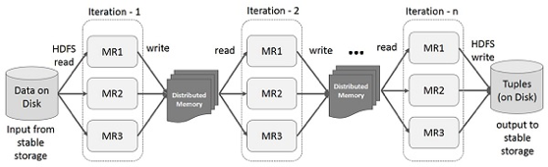
Note that the above figure is obtained from the Spark documentation. Spark RDD is an immutable, fault-tolerant distributed collection of data elements. You can imagine Spark RDD as a Hadoop HDFS in memory. Spark RDD supports two types of operations:
- Transformations, which create a new dataset from existing one
- Actions, which returns a value by performing a computation on the RDD (as shown in the next figure)
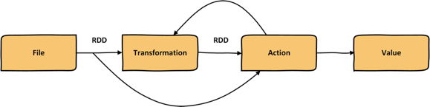
Spark RDD is created through the use of Spark transformation functions. Spark transformation functions can create Spark RDDs from various sources, such as text files. In addition to creating Spark RDDs from the text files, Spark RDDs may be created from external storage such as RDBMS, HBase, Cassandra, or any other data source compatible with Hadoop input format.
Most of the time, Spark RDDs are transformed from one RDD to another new Spark RDD in order to prepare the dataset for future processing. Let's consider the following data transformations steps in Spark:
- Load a text file with airline names and arrival times for any airport in RDD1.
- Load a text file with airline names and flight delay information for any airport into RDD2.
- Join RDD1 and RDD2 by airline names to get RDD3.
- Map on RDD3 to get a nice report for each airline as RDD4.
- Save RDD4 to file.
- Map RDD2 to extract the information of flight delay for certain airlines to get RDD5.
- Aggregate the RDD5 to get a count of how many flights are delayed for each airline as RDD6.
- Save the RDD6 into HDFS.
Spark RDDs are utilized to perform computations on an RDD dataset through Spark actions such as count or reduce. But there is a single problem with the Spark RDD: Spark RDD can't share between Spark Jobs or SparkContext because Spark RDD is bound to a Spark application. With native Spark distribution, the only way to share RDDs between different Spark jobs is to write the dataset into HDFS or somewhere in the file system and then pull the RDDs within the other jobs. However, the same functionality can be achieved by using Alluxio (formerly Tachyon) or Apache Ignite.
Apache Ignite's memory-centric architecture enables RDD sharing in a very efficient and effective way. Apache Ignite provides IgniteContext and IgniteRDD to share RDDs between Spark applications.
- IgniteContext: IgniteContext is the main entry point to the Spark-Ignite integration. To create an instance of an Ignite context, a user must provide an instance of SparkContext and a closure creating IgniteConfiguration (configuration factory). Ignite context will make sure that server or client Ignite nodes exist in all involved job instances. Alternatively, a path to an XML configuration file can be passed to IgniteContext constructor, which will be used to nodes being started.
- IgniteRDD: IgniteRDD is an implementation of Spark RDD abstraction representing a live view of Ignite cache. IgniteRDD is not immutable; all changes in the Ignite cache (regardless of whether they were caused by another RDD or by external changes in cache) will be visible to RDD users immediately. IgniteRDD utilizes the partitioned nature of Ignite caches and provides partitioning information to Spark executor. A number of partitions in IgniteRDD equals the number of partitions in the underlying Ignite cache. IgniteRDD also provides affinity information to Spark via getPrefferredLocations so that RDD computations use data locality.
In the next part of this series, we are going to install Apache Spark and do the following:
- Run the wordcount example to verify the Spark installation.
- Configure Apache Ignite to share RDDs between Spark applications.
- Run Spark applications through Spark Shell to use Ignite RDD.
- Develop a Scala Spark application to put some Ignite RDD into the Ignite cluster and pull them from another Scala Spark application.

The Dominant APIs of Spark: Datasets, DataFrames, and RDDs
While working with Spark, often we come across the three APIs: DataFrames, Datasets, and RDDs. In this blog, I will discuss the three in terms of performance and optimization. There is seamless transformation available between DataFrames, Datasets, and RDDs. Implicitly, the RDD forms the apex of DataFrame and Datasets.
The inception of the three is somewhat described below:
RDD (Spark 1.0) > Data Frame(Spark 1.3) > Dataset (Spark 1.6).
Let's begin with the Resilient Distributed Dataset (RDD).

RDD
The crux of a Spark lies in the RDD. It is an immutable distributed collection of elements partitioned across the nodes of the cluster that can be operated on in parallel with low-level APIs, allowing easy transformations and actions.

Use Cases
- On unstructured data, like streams.
- When data manipulation involves constructs of functional programming.
- The data access and processing is free of schema impositions.
- Require low-level transformations and actions.

Features of RDDs
There are several salient features of RDDs.

Versatile
It can easily and efficiently process both structured and unstructured data. It is available in several programming languages like Java, Scala, Python, and R.

Distributed Collection
It is based on MapReduce operations that are widely popular for processing and generating large sets of data in parallel using distributed algorithms on a cluster. It allows us to write parallel computations with the help of high-level operators, without the overhead of work distribution and fault tolerance.

Immutable
RDDs are a collection of records that are partitioned. A partition is a primitive unit of parallel programming in an RDD, and every partition forms a logical division of data that is immutable and generated with transformations on existing partitions.

Fault Tolerant
In the case of a loss of RDD, one can redo the transformation on that same partition and achieve the same computation results rather than do data replication across multiple nodes.

Lazy Evaluations
All transformations are lazy — they don't compute their results right away. Transformations are performed as required and are then returned to the caller program.

Drawbacks for RDDs
There's no built-in optimization engine. When working with structured data, RDDs do not take advantage of Spark’s advanced optimizers (catalyst optimizer and Tungsten execution engine). Developers need to optimize each RDD based on its characteristics attributes.
Also, unlike DataFrames and Datasets, RDDs don’t infer the schema of the data ingested — the user is required to specify it explicitly.

DataFrames
DataFrames are immutable distributed collections of data in which the data is organized in a relational manner — that is, named columns drawing parallels to tables in a relational database. The essence of datasets is to superimpose a structure on the distributed collection of data in order to allow efficient and easier processing. It is conceptually very equivalent to a table in a relational database. Along with DataFrames, Spark also uses catalyst optimizer.

Features
Following are the salient features of DataFrames.
- They are conceptually equivalent to a table in a relational database — but have richer optimizations.
- They can process structured and unstructured data formats (i.e. Avro, CSV, ElasticSearch, and Cassandra) and storage systems (i.e. HDFS, HIVE tables, and MySQL).
- They empower SQL queries and the DataFrame API.

Drawbacks of DataFrames
The DataFrame API does not support compile time safely, which limits the user when manipulating data when the structure of the data is not known.
Also, after the transformation of domain object into a DataFrame, the user cannot regenerate it.

Datasets
Datasets acquire two discrete APIs characteristics; namely, strongly typed and untyped. A DataFrame can be seen as a collection of generic type Dataset [Row], where the Row can be a generic and untyped JVM object.
Also, unlike DataFrames, Datasets are by default a collection of strongly typed JVM objects. In Java, they are mapped by class. In Scala, they are governed by case class.
Datasets provide static-type and runtime-type safety. Datasets and DataFrames allow us to catch errors at compile time. Another advantage is that DataFrames render a structured view for semi-structured data as a collection of Datasets [Row].
At the core of the API is an encoder responsible for the conversion between JVM objects and tabular representation. This representation is stored in the Tungsten Binary Format, improving memory utilization.

Features
Datasets offer the best of both worlds, including:
- Functional programming.
- Type safety.
- Query optimization.
- Encoding.

Drawbacks of DataSets
Datasets require type casting into strings. Querying currently requires specification of a class as a String and later casting of a column into a data type.
Let's now discuss the type safety figuratively:
Error | SQL | DataFrame | Datasets
Syntax error | Runtime | Compile time | Compile time
Analysis error | Runtime | Runtime | Compile time
Now, let's discuss this in terms of performance and optimization.

Performance Optimization
The DataFrame and Dataset APIs use Catalyst to generate optimized logical and physical plans under Java, Scala, or Python.
Also, the Dataset [T]-type API is optimized for engineering tasks; the DataFrame is faster and more suitable for interactive analysis.

Space Optimization
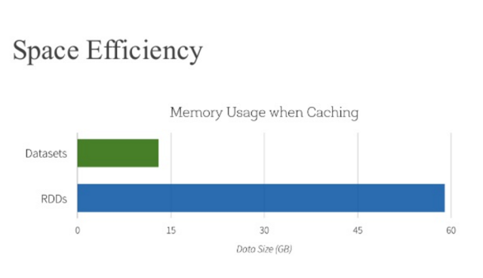
The presence of encoders in the Dataset API efficiently serializes and deserializes JVM objects to generate compact bytecode. A smaller bytecode ensures faster execution speeds.
Having discussed all the important aspects related to Spark APIs, the blog would be incomplete if I didn’t discuss the use case of each of them against the other.
When to use DataFrames or Datasets:
- Rich semantics.
- High-level abstractions.
- Domain-specific APIs.
- Processing of high-level operations (i.e. filters maps).
- Use columnar access and lambda functions on semi-structured data.
When to use Datasets:
- High-degree safety at runtime.
- Take advantage of typed JVM objects.
- Take advantage of the Catalyst optimizer.
- Save space.
- Faster execution.
When to use DataFrames:
- Low-level functionality.
- Tight control.

References
- Apache Spark SQL Programming Guide
- A Tale of Three Spark APIs: RDDs, DataFrames, and Datasets
- Apache Spark: RDD vs. DataFrame vs. Dataset

Converting Spark RDD to DataFrame and Dataset. Expert Opinion.
4 APRIL 2017
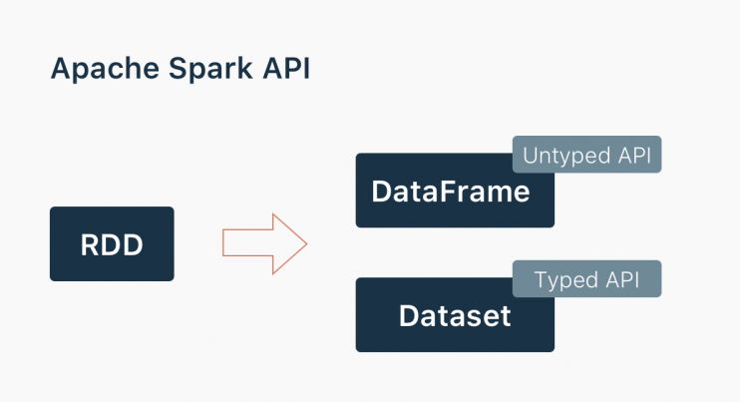
AuthorRostislav Pashuto, Vladimir Bystrov
Generally speaking, Spark provides 3 main abstractions to work with it. First, we will provide you with a holistic view of all of them in one place. Second, we will explore each option with examples.
- RDD (Resilient Distributed Dataset). The main approach to work with unstructured data. Pretty similar to a distributed collection that is not always typed.
- Datasets. The main approach to work with semi-structured and structured data. Typed distributed collection, type-safety at a compile time, strong typing, lambda functions.
- DataFrames. It is the Dataset organized into named columns. It is conceptually equivalent to a table in a relational database or a data frame in R/Python, but with richer optimizations under the hood. Think about it as a table in a relational database.
The more Spark knows about the data initially, the more optimizations are available for you.
- RDD. Raw data lacking predefined structure forces you to do most of the optimizations by yourself. This results in lower performance out of the box and requires more effort to speed up the data processing.
- Datasets. Typed data, possible to apply existing common optimizations, benefits of Spark SQL’s optimized execution engine.
- DataFrames. Share the codebase with the Datasets and have the same basic optimizations. In addition, you have optimized code generation, transparent conversions to column based format and an SQL interface.
Let’s scale up from Spark RDD to DataFrame and Dataset and go back to RDD. All examples will be in Scala. The source code is available on GitHub. We’ll try to leave comments on any tricky syntax for non-scala guys’ convenience.
Prerequisites: In order to work with RDD we need to create a SparkContext object
val conf: SparkConf =
new SparkConf()
.setMaster("local[*]")
.setAppName("AppName")
.set("spark.driver.host", "localhost")

val sc: SparkContext = new SparkContext(conf)

RDD
There are 2 common ways to build the RDD:
- Pass your existing collection to SparkContext.parallelize method (you will do it mostly for tests or POC)
scala> val data = Array(1, 2, 3, 4, 5)
data: Array[Int] = Array(1, 2, 3, 4, 5)

scala> val rdd = sc.parallelize(data)
rdd: org.apache.spark.rdd.RDD[Int] = ParallelCollectionRDD[0] at parallelize at <console>:26
- Read from external sources
val lines = sc.textFile("data.txt")
val lineLengths = lines.map(s => s.length)
val totalLength = lineLengths.reduce((a, b) => a + b)
Pretty straightforward, right? Things are getting interesting when you want to convert your Spark RDD to DataFrame. It might not be obvious why you want to switch to Spark DataFrame or Dataset. As you might see from the examples below, you will write less code, the code itself will be more expressive and do not forget about the out of the box optimizations available for DataFrames and Datasets. Imagine that you’ve done a set of transformations on unstructured data via RDD and you want to continue with a bunch of aggregations reusing the DataFrames optimizations (Catalyst optimizer and Tungsten’s efficient code generation). What options do you have? Let’s intro to DataFrames first and come back to this question.

DataFrame
DataFrame is based on RDD, it translates SQL code and domain-specific language (DSL) expressions into optimized low-level RDD operations. DataFrames have become one of the most important features in Spark and made Spark SQL the most actively developed Spark component. Since Spark 2.0, DataFrame is implemented as a special case of Dataset.
Most constructions may remind you of SQL as DSL. Naturally, its parent is HiveQL.
DataFrame has two main advantages over RDD:
- Optimized execution plans via Catalyst Optimizer.
- Custom Memory management via Project Tungsten.
Prerequisites: To work with DataFrames we will need SparkSession
val spark: SparkSession =
SparkSession
.builder()
.appName("AppName")
.config("spark.master", "local")
.getOrCreate()
First, let’s sum up the main ways of creating the DataFrame:
- From existing RDD using a reflection
In case you have structured or semi-structured data with simple unambiguous data
types, you can infer a schema using a reflection.
import spark.implicits._
// for implicit conversions from Spark RDD to Dataframe
val dataFrame = rdd.toDF()

- From existing RDD by programmatically specifying the schema
def dfSchema(columnNames: List[String]): StructType =
StructType(
Seq(
StructField(name = "name", dataType = StringType, nullable = false),
StructField(name = "age", dataType = IntegerType, nullable = false)
)
)

def row(line: List[String]): Row = Row(line(0), line(1).toInt)

val rdd: RDD[String] = ...
val schema = dfSchema(Seq("name", "age"))
val data = rdd.map(_.split(",").to[List]).map(row)
val dataFrame = spark.createDataFrame(data, schema)
- Loading data from a structured file (JSON, Parquet, CSV)
val dataFrame = spark.read.json("example.json")
val dataFrame = spark.read.csv("example.csv")
val dataFrame = spark.read.parquet("example.parquet")
- External database via JDBC
val dataFrame = spark.read.jdbc(url,"person",prop)
- Tables in Hive
If you have semi-structured data, you can create DataFrame from the existing RDD by programmatically specifying the schema.
Let’s take a look at the real-life example and review it step-by-step.
Business problem: “Happy Customers” online support center has 3 managers (Arjun Kumar, Rohit Srivastav, Kabir Vish). Smart internal system randomly picks a manager and assigns it to the new client persistently. Unfortunately, last week’s report showed a decrease in a customer satisfaction rate and you want to start your investigation with an average customer satisfaction per manager.
The dataset in table format:
Manager name, Client Name, Client Gender, Client Age, Response time (in hours), Satisfaction Level (0-1)
manager_name | client_name | client_gender | client_age | response_time | satisfaction_level
“Arjun Kumar” | “Rehan Nigam” | “male” | 30 | 4.0 | 0.5
“Kabir Vish” | “Abhinav Neel” | “male” | 28 | 12.0 | 0.1
“Arjun Kumar” | “Sam Mehta” | “male” | 27 | 3.0 | 0.7
“Arjun Kumar” | “Ira Pawan” | “female” | 40 | 2.5 | 0.6
“Rohit Srivastav” | “Vihaan Sahni” | “male” | 38 | 6.0 | 0.5
“Kabir Vish” | “Daivik Saxena” | “male” | 45 | 16.0 | 0.2
“Rohit Srivastav” | “Lera Uddin” | “female” | 20 | 8.0 | 0.4
“Rohit Srivastav” | “Aaran Puri” | “male” | 34 | 7.5 | 0.3
“Kabir Vish” | “Rudra Mati” | “male” | 50 | 20.0 | 0.1
The same in “csv”
manager_name, client_name, client_gender, client_age, response_time, statisfaction_level
“Arjun Kumar”,”Rehan Nigam”,”male”,30,4.0,0.5
“Kabir Vish”,”Abhinav Neel”,”male”,28,12.0,0.1
“Arjun Kumar”,”Sam Mehta”,”male”,27,3.0,0.7
“Arjun Kumar”,”Ira Pawan”,”female”,40,2.5,0.6
“Rohit Srivastav”,”Vihaan Sahni”,”male”,38,6.0,0.5
“Kabir Vish”,”Daivik Saxena”,”male”,45,16.0,0.2
“Rohit Srivastav”,”Lera Uddin”,”female”,20,8.0,0.4
“Rohit Srivastav”,”Aaran Puri”,”male”,34,7.5,0.3
“Kabir Vish”,”Rudra Mati”,”male”,50,20.0,0.1
We need to define a schema for the file and create the DataFrame based on it.
“Row” here represents one row of csv data output.
// create DataFrame from RDD (Programmatically Specifying the Schema)
val headerColumns = rdd.first().split(",").to[List]
// extract headers [..] first

def dfSchema(columnNames: List[String]): StructType = {
StructType(
Seq(
StructField(name = "manager_name", dataType = StringType, nullable = false),
StructField(name = "client_name", dataType = StringType, nullable = false),
StructField(name = "client_gender", dataType = StringType, nullable = false),
StructField(name = "client_age", dataType = IntegerType, nullable = false),
StructField(name = "response_time", dataType = DoubleType, nullable = false),
StructField(name = "satisfaction_level", dataType = DoubleType, nullable = fals)
)
)
}

// create a data row

def row(line: List[String]): Row = {
Row(line(0), line(1), line(2), line(3).toInt, line(4).toDouble, line(5).toDouble)
}

// define a schema for the file

val schema = dfSchema(headerColumns)

val data =
rdd
.mapPartitionsWithIndex((index, element) => if (index == 0) it.drop(1) else it) // skip header
.map(_.split(",").to[List])
.map(row)

val dataFrame = spark.createDataFrame(data, schema)
Now we can use optimized DataFrame’s aggregations. Take a look at a few lines of code. Pretty simple and, expressive. When you are using DataFrame in the right place you may get space efficiency and speed optimization. Please, refer to this blog post to get more details. Going a little bit ahead we’d like to say that Datasets are optimized for typed engineering tasks, DataFrames are faster for interactive analytics.
So, we can figure out the average customer satisfaction rate using the following code:
data
.groupBy($"manager_name")
.agg(
round(avg($"response_time"), 1).as("time"),
round(avg($"satisfaction_level"), 1).as("satisfaction")
)
.orderBy($"satisfaction")

Now it’s time to complete our investigation and show the output.
manager_name | response_time | satisfaction_level
“Kabir Vish” | 16.0 | 0.1
“Rohit Srivastav” | 7.2 | 0.4
“Arjun Kumar” | 3.2 | 0.6
Alternatively, you can solve it via Spark SQL which is a separate topic to discuss. The output will be the same. In the middle of the code, we are following Spark requirements to bind DataFrame to a temporary view. The rest looks like regular SQL. When executing SQL queries using Spark SQL, you can reference a DataFrame by its name previously registering DataFrame as a table. When you do so Spark stores the table definition in the table catalog. For Spark without Hive support, a table catalog is implemented as a simple in-memory map, which means that table information lives in the driver’s memory and disappears with the Spark session. In both cases (Spark with or without Hive support), the createOrReplaceTempView method registers a temporary table.
See the example below and try doing it. For more information, you can refer to the Spark SQL language documentation.
val viewName = s"summed"

val sql =
s"""
SELECT manager_name,
ROUND(SUM(response_time) / COUNT(response_time), 1) AS time,
ROUND(SUM(satisfaction_level) / COUNT(satisfaction_level), 1) AS satisfaction
FROM $viewName
GROUP BY manager_name
ORDER BY satisfaction

"""

// before run our SQL query we must create a temporary view
// for our DataFrame, by using following method
summed.createOrReplaceTempView(viewName)
spark.sql(sql)
SQL and DataFrames are different approaches to doing the same. Writing SQL is probably easier and more natural to users who are used to working with relational databases, or distributed databases, such as Hive. We are using SQL mostly for static queries and DataFrame API for dynamic queries for our own convenience. We encourage you to experiment and choose your style.

Dataset
The DataFrame API is radically different from the RDD API because it is an API for building a relational query plan that Spark’s Catalyst optimizer can then execute.
The Dataset API aims to provide the best of both worlds: the familiar object-oriented programming style and compile-time type-safety of the RDD API but with the performance benefits of the Catalyst query optimizer. Datasets also use the same efficient off-heap storage mechanism as the DataFrame API.
The idea behind Dataset “is to provide an API that allows users to easily perform transformations on domain objects, while also providing the performance and robustness advantages of the Spark SQL execution engine”. It represents competition to RDDs as they have overlapping functions.
DataFrame is an alias to Dataset[Row]. As we mentioned before, Datasets are optimized for typed engineering tasks, for which you want types checking and object-oriented programming interface, while DataFrames are faster for interactive analytics and close to SQL style.
About data serializing. The Dataset API has the concept of encoders which translate between JVM representations (objects) and Spark’s internal binary format. Spark has built-in encoders that are very advanced in that they generate byte code to interact with off-heap data and provide on-demand access to individual attributes without having to de-serialize an entire object.
Let’s say we have a case class
case class FeedbackRow(manager_name: String, response_time: Double, satisfaction_level: Double)
You can create Dataset:
- By implicit conversion
// create Dataset via implicit conversions
val ds: Dataset[FeedbackRow] = dataFrame.as[FeedbackRow]
val theSameDS = spark.read.parquet("example.parquet").as[FeedbackRow]
- By hand
// create Dataset by hand
val ds1: Dataset[FeedbackRow] = dataFrame.map {
row => FeedbackRow(row.getAs[String](0), row.getAs[Double](4), row.getAs[Double](5))
}
- From collection
import spark.implicits._

case class Person(name: String, age: Long)

val data = Seq(Person("Bob", 21), Person("Mandy", 22), Person("Julia", 19))
val ds = spark.createDataset(data)

- From RDD
val rdd = sc.textFile("data.txt")
val ds = spark.createDataset(rdd)
Here is an example, how to solve our sample business problem using the typed Dataset API.
// custom average aggregator, to round the final value with a scale of 1
class TypedScaledAverage[IN](f: IN => Double) extends TypedAverage[IN](f) {
override def finish(red: (Double, Long)): Double =
(red._1 / red._2 * 10).round / 10d
}

def scaledAvg[IN](f: IN => Double): TypedColumn[IN, Double] =
new TypedScaledAverage(f).toColumn

summed
.groupByKey(x => x.manager_name)
.agg(scaledAvg(_.response_time), scaledAvg(_.satisfaction_level))
.map { case (managerName, time, satisfaction) =>
FeedbackRow(managerName, time, satisfaction)
}.orderBy($"statisfaction_level")

Bringing it all together.
Despite each API has its own charm and purpose the conversions between RDDs, DataFrames, Datasets are possible and sometimes natural. We intentionally didn’t cover partitioning, shuffling, data locality and latency topics in this article to keep its size not too large. Please, consider it while working with Spark to get optimal performance. Let’s build the basic checklist when to use RDDs, DataFrames and Datasets. It will help you choose the proper way from the start.

RDD
- your data is unstructured, for example, binary (media) streams or text streams
- you want to control your dataset and use low-level transformations and actions
- your data types cannot be serialized with Encoders (an optimized approach that uses runtime code generation to build custom bytecode for serialization and deserialization)
- you are ok to miss optimizations for DataFrames and Datasets for structured and semi-structured data that are available out of the box
- you don’t care about the schema, columnar format and ready to use functional programming constructs

DataFrame
- your data is structured (RDBMS input) or semi-structured (json, csv)
- you want to get the best performance gained from SQL’s optimized execution engine (Catalystoptimizer and Tungsten’s efficient code generation)
- you need to run hive queries
- you appreciate domain specific language API (.groupBy, .agg, .orderBy)
- you are using R or Python

Dataset
- your data is structured or semi-structured
- you appreciate type-safety at a compile time and a strong-typed API
- you need good performance (mostly greater than RDD), but not the best one (usually lower than DataFrames)
This’s it! Thank you for reading our post. Hopefully, it was useful for you to explore the process of converting Spark RDD to DataFrame and Dataset.
We regularly write about data science, Big Data, and Artificial Intelligence. If you would like to read future posts from our team then simply subscribe to our monthly newsletter. Also feel free to connect on Twitter

Reading Data From Oracle Database With Apache Spark
In this article, I will connect Apache Spark to Oracle DB, read the data directly, and write it in a DataFrame.
Following the rapid increase in the amount of data we produce in daily life, big data technology has entered our lives very quickly. Instead of traditional solutions, we are now using tools with the capacity to solve our business quickly and efficiently. The use of Apache Spark is a common technology that can fulfill our needs.
Apache Spark is based on a framework that can process data very quickly and distributedly. In this article, I will not describe Apache Spark technology in detail, so those who are interested in the details should check out the Apache Spark documentation.
The preferred method to process the data we store in our RDBMS databases with Apache Spark is to migrate the data to Hadoop first (HDFS), distributively read the data we have stored in Hadoop (HDFS), and process it with Apache Spark. As those with Hadoop ecosystem experience know, we are exchanging data between the Hadoop ecosystem and other systems (RDBMS-NoSQL) with tools that integrate into the Hadoop ecosystem with Sqoop. Sqoop is a data transfer tool that is easy to use, common, and efficient.
There is some cost involved in moving the data to be processed to the Hadoop environment before the RDBMS, and then importing the data to be processed with Apache Spark. The fact that we do not use the data that we have moved to HDFS will cause us to lose a certain amount of space in HDFS, and it will also increase the processing time. Instead of this method, there is a way with Apache Spark that reads and uses the RDBMS directly without having to go to the HDFS and store it there — especially afterward.
Let's see how to do this.
The technologies and versions I used are as follows:
- Hadoop: Hadoop 2.7.1
- Apache Spark: Apache Spark 2.1.0
- Oracle database: Oracle 11g R2, Enterprise Edition
- Linux: SUSE Linux
To do this, we need to have the ojdbc6.jar file in our system. You can use this link to download it.
We will create tables in the Oracle database that we will read from Oracle and insert sample data in them.
CREATE TABLE EMP
(
EMPNO NUMBER,
ENAME VARCHAR (10),
JOB VARCHAR (9),
MGR NUMBER,
SAL NUMBER,
COMM NUMBER,
DEPTNO NUMBER
);
INSERT INTO EMP VALUES
(7369, 'SMITH', 'CLERK', 7902, 800, 50, 20);
INSERT INTO EMP VALUES
(7499, 'ALLEN', 'SALESMAN', 7698, 1600, 300, 30);
INSERT INTO EMP VALUES
(7521, 'WARD', 'SALESMAN', 7698, 1250, 500, 30);
INSERT INTO EMP VALUES
(7566, 'JONES', 'MANAGER', 7839, 2975, NULL, 20);
INSERT INTO EMP VALUES
(7654, 'MARTIN', 'SALESMAN', 7698, 1250, 1400, 30);
INSERT INTO EMP VALUES
(7698, 'BLAKE', 'MANAGER', 7839, 2850, NULL, 30);
INSERT INTO EMP VALUES
(7782, 'CLARK', 'MANAGER', 7839, 2450, NULL, 10);
INSERT INTO EMP VALUES
(7788, 'SCOTT', 'ANALYST', 7566, 3000, NULL, 20);
INSERT INTO EMP VALUES
(7839, 'KING', 'PRESIDENT', NULL, 5000, NULL, 10);
INSERT INTO EMP VALUES
(7844, 'TURNER', 'SALESMAN', 7698, 1500, 0, 30);
INSERT INTO EMP VALUES
(7876, 'ADAMS', 'CLERK', 7788, 1100, NULL, 20);
INSERT INTO EMP VALUES
(7900, 'JAMES', 'CLERK', 7698, 950, NULL, 30);
INSERT INTO EMP VALUES
(7902, 'FORD', 'ANALYST', 7566, 3000, NULL, 20);
INSERT INTO EMP VALUES
(7934, 'MILLER', 'CLERK', 7782, 1300, NULL, 10);
CREATE TABLE DEPT
(
DEPTNO NUMBER,
DNAME VARCHAR (14),
LOC VARCHAR (13)
);
INSERT INTO DEPT VALUES (10, 'ACCOUNTING', 'NEW YORK');
INSERT INTO DEPT VALUES (20, 'RESEARCH', 'DALLAS');
INSERT INTO DEPT VALUES (30, 'SALES', 'CHICAGO');
INSERT INTO DEPT VALUES (40, 'OPERATIONS', 'BOSTON');
COMMIT;
Now we are starting Apache Spark from the linux terminal with Pyspark interface (Python Interface).
/spark-2.1.0-bin-hadoop2.7/bin/pyspark
--jars "/home/jars/ojdbc6.jar"
--master yarn-client
--num-executors 10
--driver-memory 16g
--executor-memory 8g
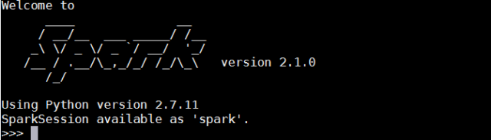We started Apache Spark. Now let's write the Python code to read the data from the database and run it.
empDF = spark.read \
.format("jdbc") \
.option("url", "jdbc:oracle:thin:username/password@//hostname:portnumber/SID") \
.option("dbtable", "hr.emp") \
.option("user", "db_user_name") \
.option("password", "password") \
.option("driver", "oracle.jdbc.driver.OracleDriver") \
.load()
Let's take a look at the contents of this dataframe as we write to the empDF dataframe.
empDF.printSchema()
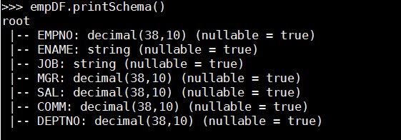
empDF.show()
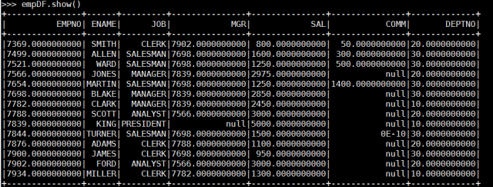
Yes, I connected directly to the Oracle database with Apache Spark. Likewise, it is possible to get a query result in the same way.
query = "(select empno,ename,dname from emp, dept where emp.deptno = dept.deptno) emp"
empDF = spark.read \
.format("jdbc") \
.option("url", "jdbc:oracle:thin:username/password@//hostname:portnumber/SID") \
.option("dbtable", query) \
.option("user", "db_user_name") \
.option("password", "password") \
.option("driver", "oracle.jdbc.driver.OracleDriver") \
.load()
empDF.printSchema()
empDF.show()
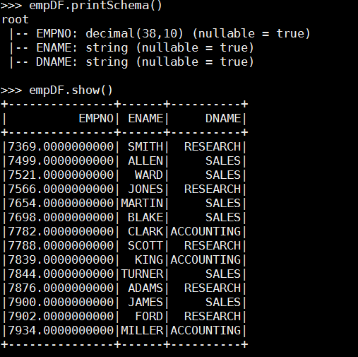
It is very easy and practical to use, as you can see from the examples made above.
With this method, it is possible to load large tables directly and in parallel, but I will do the performance evaluation in another article.

Apache Parquet vs. CSV Files
You have surely read about Google Cloud (i.e. BigQuery, Dataproc), Amazon Redshift Spectrum, and Amazon Athena. Now, you are looking to take advantage of one or two. However, before you jump into the deep end, you will want to familiarize yourself with the opportunities of leveraging Apache Parquetinstead of regular text, CSV, or TSV files. If you are not thinking about how to optimize for these new query service models, you are throwing money out the window.

What Is Apache Parquet?
Apache Parquet is a columnar storage format with the following characteristics:
- Apache Parquet is designed to bring efficient columnar storage of data compared to row-based files like CSV.
- Apache Parquet is built from the ground up with complex nested data structures in mind.
- Apache Parquet is built to support very efficient compression and encoding schemes.
- Apache Parquet allows for lower data storage costs and maximized effectiveness of querying data with serverless technologies like Amazon Athena, Redshift Spectrum, and Google Dataproc.
Parquet is a self-describing data format that embeds the schema or structure within the data itself. This results in a file that is optimized for query performance and minimizing I/O. Parquet also supports very efficient compression and encoding schemes.

Parquet and the Rise of Cloud Warehouses and Interactive Query Services
The rise of interactive query services like Amazon Athena, PrestoDB and Redshift Spectrum makes it easy to use standard SQL to analyze data in storage systems like Amazon S3. If you are not yet sure how you can benefit from those services, you can find more information in this intro post about Amazon Redshift Spectrum and this post about Amazon Athena features and benefits. Also, data warehouses like Google BigQuery and the Google Dataproc platform can leverage different formats for data ingest.
The data format you select can have significant implications on performance and cost. We will walk you through a few examples of those considerations.

Parquet vs. CSV
CSV is simple and ubqitous. Many tools like Excel, Google Sheets, and a host of others can generate CSV files. You can even create them with your favoritre text editing tool. We all love CSV files, but everything has a cost — even your love of CSV files, especially if CSV is your default format for data processing pipelines.
- Amazon Athena and Spectrum charge you by the amount of data scanned per query. (Many other services also charge based on data queried, so this is not unique to AWS.)
- Google and Amazon charge you for the amount of data stored on GS/S3.
- Google Dataproc charges are time-based.
Defaulting to the use of CSV will have both technical and financial outcomes (not in a good way). You will learn to love Parquet just as much as your trusty CSV.

Example: A 1 TB CSV File
The following demonstrates the efficiency and effectiveness of using a Parquet file vs. CSV.
By converting your CSV data to Parquet’s columnar format and then compressing and partitioning it, you save money and reap the rewards of better performance. The following table compares the savings created by converting data into Parquet vs. CSV.
If over the course of a year, you stick with the uncompressed 1 TB CSV files as foundation of your queries, your costs will be $2,000. Using Parquet files, your total cost will be $3.65. I know you love your CSV files, but do you love them that much?
Also, if time is money, your analysts can be spending close to five minutes waiting for a query to complete simply because you use raw CSV. If you are paying someone $150 an hour and they are doing this once a day for a year then they spent about 30 hours simply waiting for a query to complete. That is roughly about $4,500 in unproductive “wait” time. Total wait time for the Apache Parquet user? About 42 mins or $100.

Example 2: Parquet, CSV, and Your Redshift Data Warehouse
Amazon Redshift Spectrum enables you to run Amazon Redshift SQL queries against data in Amazon S3. This can be an effective strategy for teams that want to partition data when some of it resides within Redshift and other data resides on S3. For example, let’s assume you have about 4 TB of data in a historical_purchase table in Redshift. Since it's not accessed frequently, offloading it to S3 makes sense. This will free up that space in Redshift while still providing your team access via Spectrum. Now, the big question becomes: What format are you storing that 4 TB historical_purchase table in? CSV? How about using Parquet?
historical_purchase table has four equally sized columns, stored in Amazon S3 in three files: uncompressed CSV, GZIP CSV, and Parquet.
- Uncompressed CSV file: The uncompressed CSV file has a total size of 4 TB. Running a query to get data from a single column of the table requires Redshift Spectrum to scan the entire file 4 TB. As result, this query will cost $20.
- GZIP CSV file: If you compress your CSV file using GZIP, the file size is reduced to 1 GB. Great savings! However, Redshift Spectrum still has to scan the entire file. The good news is your CSV file is four times smaller than the uncompressed one, so you pay one fourth of what you did before. So this query will cost $5.
- Parquet file: If you compress your file and convert it to Apache Parquet, you end up with 1 TB of data in S3. However, because Parquet is columnar, Redshift Spectrum can read only the column that is relevant for the query being run. It only needs to scan just one-fourth of the data. This query would only cost $1.25.
If you are running this query once a day for a year, using uncompressed CSV files will cost $7,300. Even compressed CSV queries will cost over $1,800. However, using the Apache Parquet file format, it will cost about $460. Still in love with your CSV file?

Summary
The trend toward “serverless,” interactive query services, and zero administration pre-built data processing suites is rapidly progressing. It is providing new opportunities for teams to go faster with lower investments. Athena and Spectrum make it easy to analyze data in Amazon S3 using standard SQL. Also, Google supports loading Parquet files into BigQuery and Dataproc.
When you only pay for the queries that you run, or resources like CPU and storage, it is important to look at optimizing the data those systems rely on.

Oracle RDBMS + Neo4j: Fully Sync Relational and Graph Data
Using the Neo4j graph database doesn’t have to be opposed to your existing Oracle RDBMS infrastructure. In fact, the two can work together.
One of many ways Neo4j works alongside Oracle RDBMS is to have all data fully synchronized between the two database technologies.
In this Neo4j and Oracle blog series, we’ll explore how these two database technologies work together in tandem to deliver the best bottom-line results for both enterprise architects and business teams alike. In previous weeks, we defined and introduced both Neo4j and Oracle RDBMS, we covered three advantages of using Neo4j with Oracle, and we explored how to migrate or sync a subset of your data between them.
This week, we’ll discuss the advantages of fully synchronizing the data between your Oracle RDBMS and Neo4j, including an example of how Monsanto (a customer of both Oracle and Neo4j) fully syncs their data between the two.

Why Sync Your Data?
Applications that integrate data from multiple data sources are a common use case for full synchronization. Another use case for a full synchronization arises when you have an existing set of applications writing to an Oracle database and changing those applications is cost prohibitive. For the data to add increasing value, new technologies need to be introduced where the Oracle RDBMS is incapable. This was the case for Monsanto.

Syncing Neo4j and Oracle Exadata
Monsanto is a multinational agrochemical and agricultural biotechnology company. Prior to adopting Neo4j, Monsanto relied on a 96-CPU Oracle Exadata installation to host its core genetic ancestry data with plenty of stored procedures, JOIN tables, recursive queries and dual indexes to optimize performance.
The Monsanto team was well-versed in Oracle tuning and optimization, with over 30 years’ experience of tuning Oracle RDBMS between them all. However, the Exadata instance regularly failed to process genetic ancestry data in real time — a prerequisite if the team was to use a new genomic testing technique that could take a full year off of its time-to-market cycle.
The team’s first attempt to generate real-time results was to build and parse gigantic in-memory graphs. But once a query was complete, the graphs disappeared. The team looked for a way to persist graph data over the long term and found Neo4j.
Within one day of discovering Neo4j, the team built a prototype with a small dataset. A month later, the team had the entire genetic ancestry dataset in the graph database for a beta-release application. However, even with the Neo4j deployment in full production, dozens of applications continued to read and write data to the Exadata environment. Instead of turning off these database connections all at once, the team built a custom API layer to sync the stream of information to and from Exadata with Neo4j.
The team then introduced a valuable new query interface where their data scientists could execute deeply connected queries in a simple, keyword-driven way that wasn’t previously possible with SQL algorithms. The architecture uses Apache Kafka as a distributed commit log to feed Neo4j with live transactional data from Oracle; the team built an Oracle GoldenGate and Kafka connector, which they open sourced and made available on GitHub.

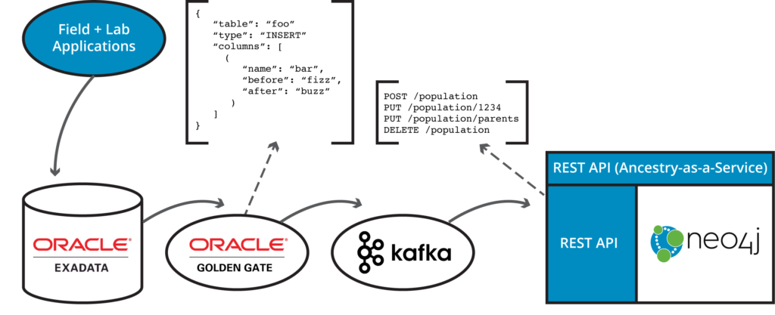

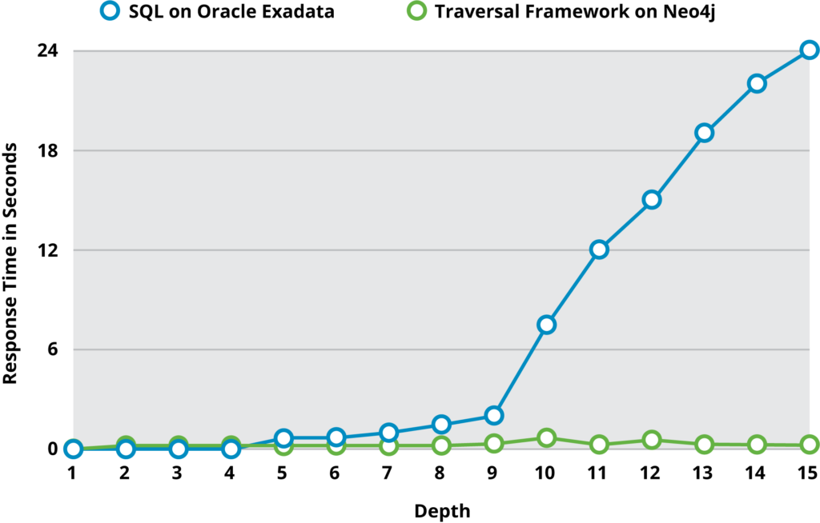Next week, we’ll look at the final way to use Neo4j alongside Oracle RDBMS: a full data migration from one to the other with several customer case studies with the specifics of each migration.

BigQuery vs Redshift: Pricing Strategy
In this article, we’re going to break down BigQuery vs Redshift pricing structures and see how they work in detail.
You can also join a free webinar on managing BigQuery performance and costs.

Redshift Pricing
Redshift pricing is pretty simple to understand. They charge as usual for AWS: per machine, per hour. The cheapest Redshift cluster you can spin up will cost you $0.25 per hour or about $180 per month. It’ll contain one dc2.large node in the US region. AWS constantly updates prices, so please check their site for up-to-date information.
Storage is bound to computing power for Redshift, unlike EC2 deployments. This means Redshift pricing will depend on your data size. Per TB, pricing is $0.425/TB/hour for HDD storage and $1.5625/TB/hour for SSD storage.
So, the cheapest pricing is $306/TB/mo. This is on-demand pricing, and as usual, AWS provides significant discounts if you pay upfront. Also, there’s separate Redshift Spectrum pricing, which is out of scope for this post.

BigQuery Pricing
BigQuery pricing is much more complicated compared to Redshift. BigQuery charges separately for storage at $20/TB/month and $5/TB processed in query. Ingestion into a BigQuery warehouse is usually free of charge, but this is not the case for data streaming. You can check updated BigQuery pricing.
Bytes processed in query, also known as bytes billed, are pretty tricky to understand, and this usually makes up about 95% of your BigQuery costs. Let’s review some simple SQL queries to see how BigQuery calculates it.

Bytes Billed Explained
BigQuery uses columnar storage, and bills are based on scanned data within columns and not within rows. We’ll review a simple count query on the sample Hacker News BigQuery dataset, which is publicly available.
SELECT count(*) FROM `bigquery-public-data`.hacker_news.fullIt will cost you $0 because no columns are processed in this query.
Let’s introduce a column here:
SELECT max(timestamp) FROM `bigquery-public-data`.hacker_news.full
This query will cost you 130MB. Here and below, we’re using bytes billed cost for the sake of simplicity. This price is calculated as total "timestamp" column size. A data type for the "timestamp" column is "TIMESTAMP," which is 8 bytes. So there are about 16M timestamps stored in this column, which correlates with 17M of rows in this table.
Note that the "timestamp" column is not stored for every row due to the nature of BigQuery’s Capacitor storage format.
A much more interesting use case is filtering. Look at the billing for this query:
SELECT max(timestamp) FROM `bigquery-public-data`.hacker_news.full WHERE timestamp BETWEEN '2015-01-01' AND '2015-02-01'
You may expect that such a query allows you to reduce the costs, but actually, it doesn’t. It’ll be the same 130MB. When a column is involved in a query, BigQuery calculates data as a whole column scan. This happens even if BigQuery doesn’t scan this data due to internal storage optimizations. In this case, querying performance and pricing aren’t aligned.
So how can query costs be reduced for such a filtering query? This is where BigQuery sharding and partitioning come into play. BigQuery sharding is implemented as wildcard table querying. It works as a UNION ALL operation on a scale. You can query at once up to 1000 tables with a specified suffix. This approach is fast as well as cost-effective.
Here is an example query on a NOAA Global Surface Summary of the Day Weather Data dataset:
SELECT max(temp) FROM `bigquery-public-data`.noaa_gsod.`gsod*` WHERE _TABLE_SUFFIX BETWEEN '2010' AND '2018'
Unlike in the previous example, costs will be reduced to the size of columns of tables starting with "gsod2010" up to "gsod2018." It’ll be 262MB instead of 1.11GB in the case where all tables are scanned. BigQuery partitioning works in a pretty same way but it’s not separated, unlike sharding tables.

Leveraging Multi-Stage Querying
Partitioning and sharding are not the only way to reduce your BigQuery costs. From our perspective, they are not the main one either. Let’s consider an upgraded version of the previous example.
SELECT CONCAT(year, '-', mo, '-', da), max(temp)
FROM `bigquery-public-data`.noaa_gsod.`gsod*`
WHERE CONCAT(year, '-', mo, '-', da) BETWEEN '2010-01-01' AND '2018-01-01' GROUP BY 1
It’ll cost you 3.04GB. If you use a table suffix filter instead of a date filter, you can reduce costs to 720MB per query. In such types of queries, the date filter is usually variable, which leads to a lot of queries. Although the table suffix filter allows you to reduce costs dramatically, they will still be high if you query too often. The typical solution here is to introduce a roll-up table first and then query it.
At the moment, BigQuery doesn’t support the CREATE TABLE AS statement, but it does support load jobs, which you can use to create a table from an SQL query.
So, for our query we can introduce the following roll up table:
SELECT CONCAT(year, '-', mo, '-', da) as date, max(temp) as max_temp
FROM `bigquery-public-data`.noaa_gsod.`gsod*`
GROUP BY 1
And to query it, we can run something like:
SELECT date, max(max_temp)
FROM rollups.max_temp_rollup
WHERE date BETWEEN '2010-01-01' AND '2018-01-01' GROUP BY 1
The first query costs us 3.04GB, which is obviously more than in the case of table suffix filtering. On the other hand, the second query is 634KB, which is at least 1000 times less than suffix filtering. So even if you use this query often, it won’t significantly affect your bill.

Conclusion
As you see, there is no absolute winner in the Bigquery vs Redshift comparison. On-demand Redshift may cost you from $10/TB/ day no matter how intensive the workload is. Meanwhile, BigQuery will allow you to query only about 10-50 queries per 1TB of data stored for that price per day. At the same time, we saw a lot of BigQuery deployments, which are at least 4 times cheaper than Redshift due to multi-stage querying.
This means that if you are not cautious about queries issued to BigQuery, it’ll become much more expensive than the Redshift option pretty fast.

Spark UDFs with multiple parameters that return a struct
I had trouble finding a nice example of how to have a udf with an arbitrary number of function parameters that returned a struct. So I’ve written this up.
There are three components of interest: case class + schema, user defined function, and applying the udf to the dataframe.

The Case Class and Schema
case class TemperatureNote(timeStamp: Timestamp, fahrenheit: Long, message: String)
val temperatureNoteSchema = new StructType()
.add("time_stamp", TimestampType)
.add("fahrenheit", LongType)
.add("message", StringType)
In this example TemperatureNote is the class we will be returning from our UDF. The schema provides the names of the columns created and their associated types. For example, even though the field name for the timestamp is “timeStamp” the column name will be “time_stamp”. The schema must match the case class exactly type wise.
The User Defined Function
private val parseTempEntryUDF = udf((file: String, notes: String) => {
val noteArray = notes.split("(: |F)")
val dateFromFile = file.split('.').head
val date = formatter.parseMillis(s"$dateFromFile ${noteArray(0)}")
TemperatureNote(new Timestamp(date), noteArray(1).trim.toLong, noteArray(2).trim)
}, temperatureNoteSchema)
Creating the udf is very straightforward, simply pass in a function that returns an instance of the case class we created and the associated schema. The input can be an arbitrary number of parameters with associated spark sql types.

The UDF in Action
val exampleDF = Seq(
("20180914.txt", "04:45:03: 78F A rainy day"),
("20180913.txt", "15:35:29: 70F A sunny day"),
("20180915.txt", "05:01:02: 24F A snowy day"))
.toDF("file", "notes")
.withColumn("parsed_note", parseTempEntryUDF($"file", $"notes"))
.select(
$"parsed_note.time_stamp".as("ts"),
$"parsed_note.fahrenheit".as("degrees"),
$"parsed_note.message".as("msg"))
.sort($"ts".desc)
.show(false)
+-------------------+-------+-----------+
|ts |degrees|msg |
+-------------------+-------+-----------+
|2018-09-15 05:01:02|24 |A snowy day|
|2018-09-14 04:45:03|78 |A rainy day|
|2018-09-13 15:35:29|70 |A sunny day|
+-------------------+-------+-----------+
I’ve been using udfs to parse poorly structured text from log files in the above fashion. The udf return value becomes a nested object inside the specified column, and you can simply select into it.
The Entire Example
import java.sql.Timestamp
import org.apache.spark.sql.SparkSession
import org.apache.spark.sql.functions.udf
import org.apache.spark.sql.types._
import org.joda.time.format.DateTimeFormat
object UDFExample extends App {
case class TemperatureNote(timeStamp: Timestamp, fahrenheit: Long, message: String)
val temperatureNoteSchema = new StructType()
.add("time_stamp", TimestampType)
.add("fahrenheit", LongType)
.add("message", StringType)
private val formatter = DateTimeFormat.forPattern("yyyyMMdd HH:mm:ss")
private val parseTempEntryUDF = udf((file: String, notes: String) => {
val noteArray = notes.split("(: |F)")
val dateFromFile = file.split('.').head
val date = formatter.parseMillis(s"$dateFromFile ${noteArray(0)}")
TemperatureNote(new Timestamp(date), noteArray(1).trim.toLong, noteArray(2).trim)
}, temperatureNoteSchema)
val spark = SparkSession.builder()
.master("local")
.getOrCreate()
import spark.sqlContext.implicits._
val exampleDF = Seq(
("20180914.txt", "04:45:03: 78F A rainy day"),
("20180913.txt", "15:35:29: 70F A sunny day"),
("20180915.txt", "05:01:02: 24F A snowy day"))
.toDF("file", "notes")
.withColumn("parsed_note", parseTempEntryUDF($"file", $"notes"))
exampleDF
.select(
$"parsed_note.time_stamp".as("ts"),
$"parsed_note.fahrenheit".as("degrees"),
$"parsed_note.message".as("msg"))
.sort($"ts".desc)
.show(false)
}

